Database Design Review

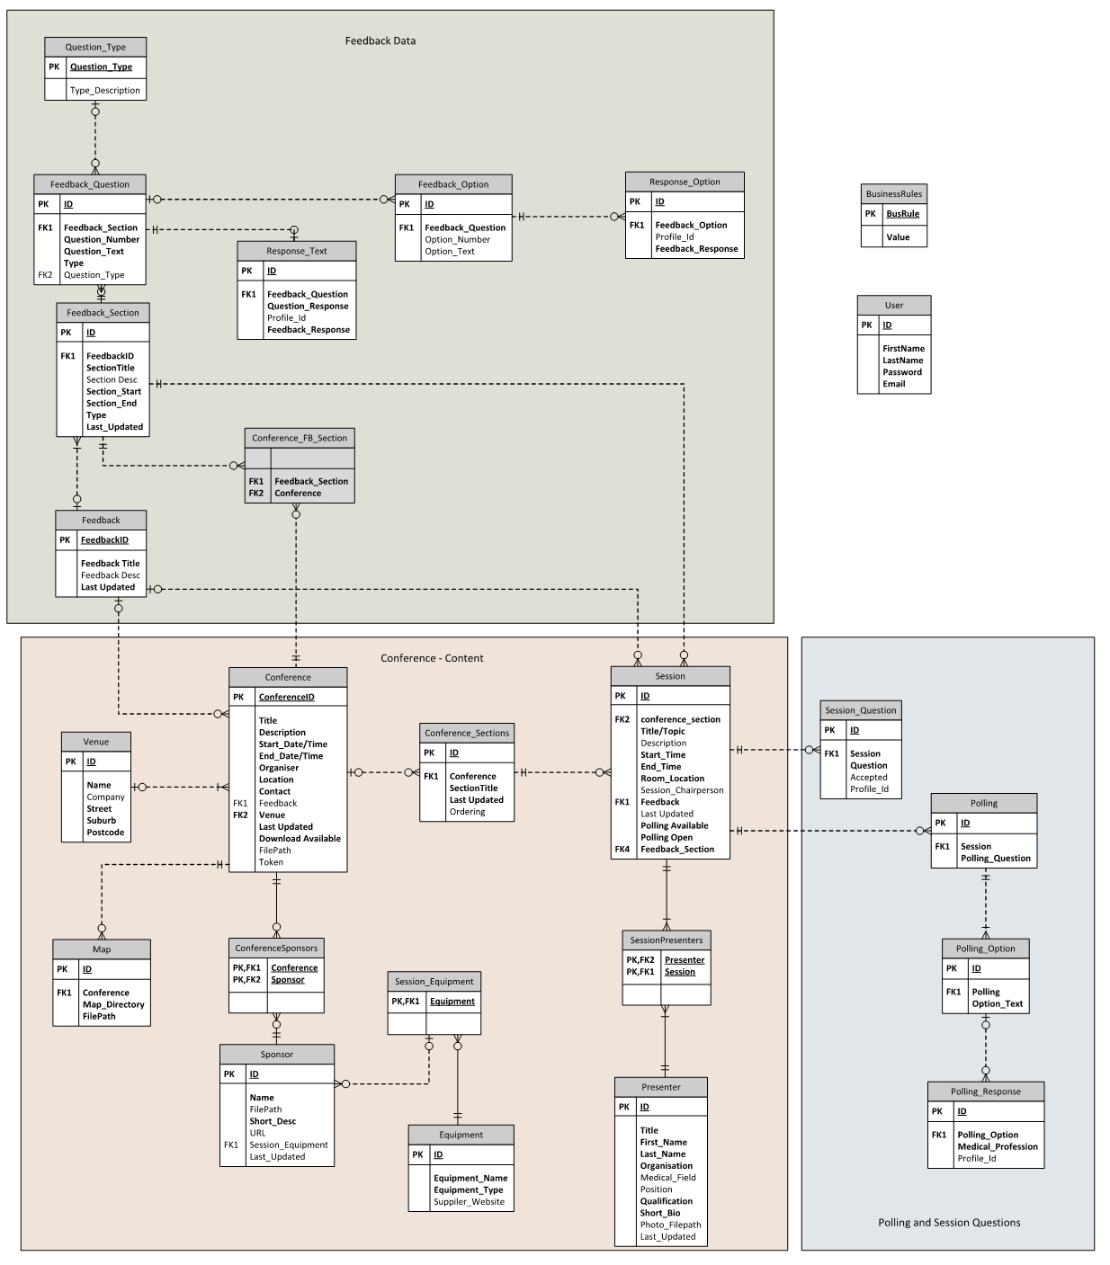

From what I understand of the system, based on my analysis the database appears to support all the requirements of the system. However the necessity of some tables are questionable. For example:

* The Feedback, Feedback_Section and Conference_FB_Section could probably be consolidated into two tables
* The Question_Type table could easily just be an integer in the Feedback_Question table rather than a whole linked table
* I haven’t found a purpose for the BusinessRules table yet
* The Conference table does not need the Location field because it is in the Venue table

However my knowledge of the system is limited and this analysis may change as I come to understand the system better, and it already seems to fulfil the requirements, so at this stage I will leave the database design as it is.